09 Omnifood Project _ Effects, Optimizations and Deployment

139 A Short Introduction to JavaScript

* The programming language of the web.

140 Making the Mobile Navigation Work

Prettier (the extension that fromats out HTML and CSS code does also format JavaScript.

* Linking the script:
* <script defer src="/js/script.js"></script>
  + Check what “defer” attribute does
* Make sure that the close button is always on top of this navigation. (exactly for that purpose we have the z index property
* *z-index*: 9999;
  + (check what it does)
* **z-index**
* The **z-index** CSS property sets the z-order of a [positioned](https://developer.mozilla.org/en-US/docs/Web/CSS/position) element and its descendants or flex and grid items. Overlapping elements with a larger z-index cover those with a smaller one.

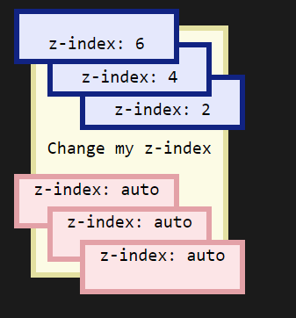

141 Implementing Smooth Scrolling

It can be done only with HtmL and CSS. It works for sure in google chrome but not sure if it will works in every browser(safari).

Segmenteaza elefantul sa il poti manca cu lingurita.

* Pentru toate linkurile trebuie sa prevenim comportamentul “Default”
* Then read basically the href attribute out of the link that was clicked (because we will then use href to actually scroll to the corespondin section )
  + *const* href = *link*.getAttribute('href');

142 Implementing a Sticky Navigation Bar

There are multiple ways for doing this but we will use the next one:

IntersectionObserver = the most modern and the best way for doing a sticky navigation.

+ notite caiet despre cod

143 Browser Support and Fixing Flexbox Gap in Safari

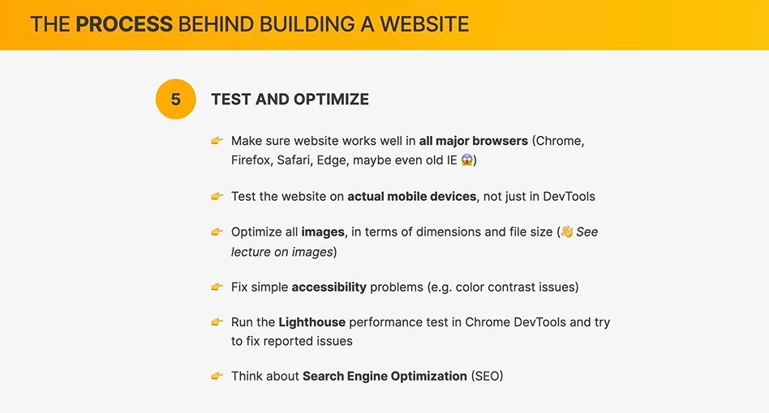

Talking about browsers support 🡪 saying browsers support it basically means how different web browsers support different CSS properties.

Back in the day, like some 10 years ago, there used to be a ton of inconsistencies between browsers.

* So out websites would look completely different in different browsers.
* And that was simply because some browsers didn’t implement some of the modern properties that we are using at the time.
* That days are now over. (almost because for old browsers like IE or Safari we still have some properties that not work

[www.caniuse.com](http://www.caniuse.com)

* Here we can input any CSS property ( for example we can check CSS Grid )

Backdrop filter – quite a very modern property which are not supported by firefox at all. ( not even tha latest versions)

144 Testing Performance With Lighthouse

The “**Lighthouse**” tool is basically an automated tool that we can use to improve the quality of our pages.

* It was developed by google and therefore it is available in out dev tools.

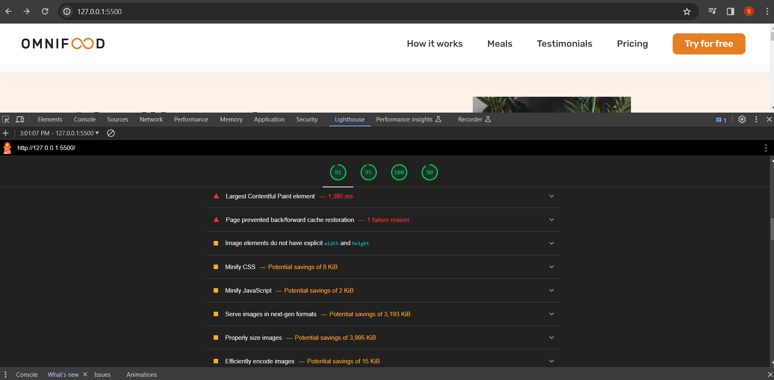

145 Adding Favicon and Meta Description

Meta description = its basically a short summary of our website’s content.

* Its also the text that will appear for each of the search results in Google and other search engines.
  + Too add that we will use the <meta> element.
  + *meta stands for metadata* which is essentially data that describes other data.
* This is the “official way” to add this> (there are other ways)

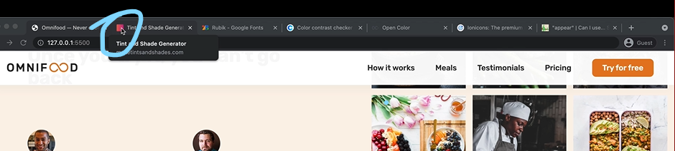

Favicon

That’s all for the browser part.

But there are actually ways of adding a website, basically as a favorite to iOS devives and also to Android devices.

There is actually an option on both these operating systems that we can basically add a website to the home screen. And so for that we will need to provide a special icon.

* + Starting with iOS we need one – 118 kinda hard rule for android
  + And for Android we need 2 – 192 and 512

146 Image Optimizations

How we can and shoul optimize the images in term of dimensions and kilobytes. *both

* The actual size of image should actually be double of the size that is actually displayed on the screen.
  + The reason why we need an IMAGE THAT IS DOULBLE SIZE the size that is actually displayed on the screen is that these high density screens actually need two pixels og the image to display one pixel in the design.

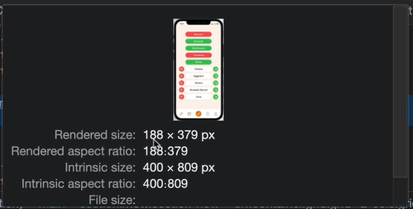

Rendered size:

Intrinsic size: the actual size of the image/

1st part of optimization process:

Resizeing:

* We start with a really big image if we have it. (probably like thousand pixels or so wide)
* Then when I finished the design, checking out the largest with that image we’ll ever have 🡪 188 px
* Then rounded to 200 and doubled it 🡪400px
* Then went ahead and resize the image. Width 400px

2nd part of optimization:

Compressing: (2mb is way to much 🡪 we can check the entire size of the ppage by coming here to the nertwork tab and then reloading )

* SQUOOSH = the tool we can use to compress images

147 Deployment to Netlify

* GoDaddy or Hover for website domain.
  + Hover.com used by Jonas.
* By default netlify comes with security 🡪 you get an HTTPs certificate that Netliffy will then basically update for you every couple of month.
* We can use the Netlify for our form to make it work also. ------🡪

148 Making the Form Work With Netlify Forms

* Using the Netlify form feature
* 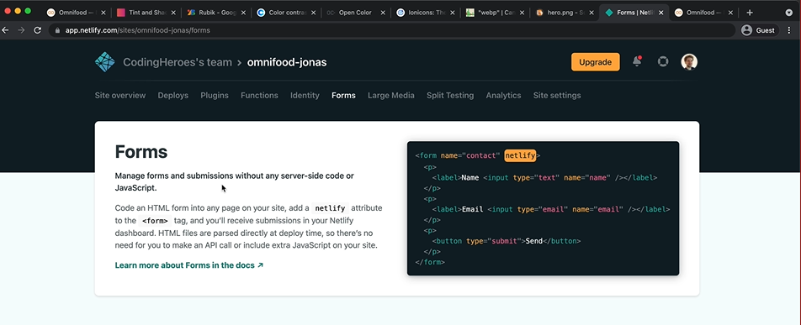
* Usually we need some code on some backend, server side to then receive form submissions.
* We need also a name attribute to each of these input fields. And a name attribute is actually a standard HTML attribute for form inputs. Actually we should have done earlier because even when we write our own server side code we still that name.
  + - Bcz that is how we will then identify each of the input fields.
* Important piece of advice:
  + You should never use a Netlify form to handle a real sign-up with password or the same thing ffor log in (Netlify have a different paid feature for this)

10. The end

149 Where to Go from Here

* PUT THESE SKILLS IN A HARD WORK AND PRACTICE PRACTICE PRACTICE
  + Recreating some layouts
  + In web development you can not stop learning

Next step learn Js:

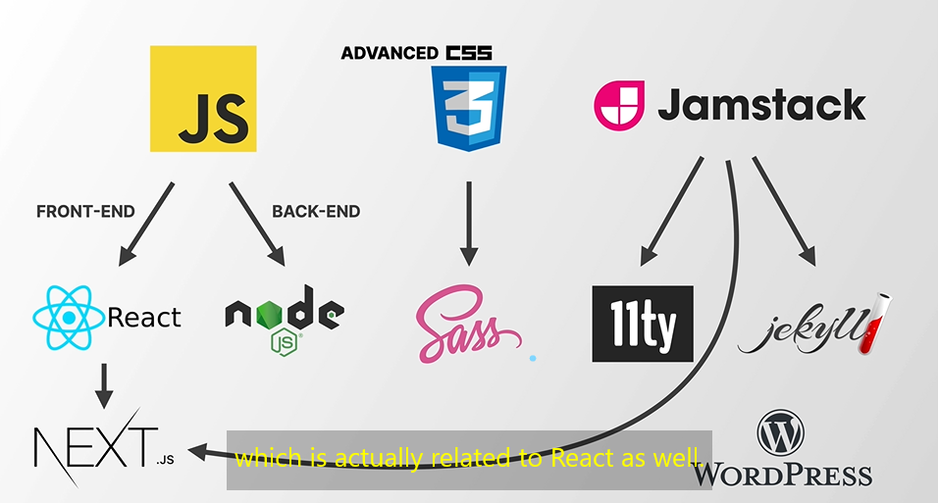

Fig”end”: High level overview roadmap.